Photosensitive module

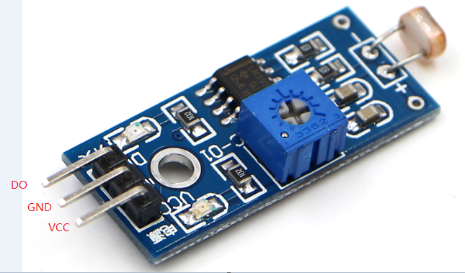

Photosensitive module Arduino controller

DO 3

GND GND

VCC VCC